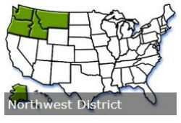
1995-2018
Northwest District
Presidential Recognition Awards

Year Award Winner School/Location
1995 Helen Chrest Helena, Montana
Jeri Domme Helena, Montana
Robert Michael Oregon State University, Corvallis
Keith Lewis
Deve Swaim Portland State University, Oregon
1996 Jeff Carpenter Olympia, Washington

